Sacramento Archeological Society, Inc.

Newsletter
------------------------------------------------------------------------------------------------------------------------------------------------
www.sacarcheology.org. February 2007
------------------------------------------------------------------------------------------------------------------------------------------------

Mysterious South America
“Machu Pichu, Lines of Nazca, Galapagos”
March 3, 2007
6:00 p.m. Dennis Fenwick’s home

Enjoy the investigation of ancient culture in South America on Saturday, March 3 at Dennis Fenwick’s home on 2825 Butler Court, West Sacramento, Phone: 916/274-2909. Society members, Gordon and Carolyn McGregor will be sharing their most recent experiences at Machu Pichu, Plains of Nazca and Galapagos. Through pictures they will extend the exploration of Peru and Galapagos Islands.

Bring your favorite dish for a potluck 6:00 p.m. The presentation will follow dinner at approximately 7:00 p.m.

Sutter Buttes
Native Ways Hike
Led by
Diana Almenderiz
March 24, 2007
8:00 a.m. to 3:30 p.m.

On March 24th Society members will be joining Diana Almenderiz, the Native American “Tule Lady” in an “easy” hike to explore the Spring plants of Sutter Buttes. Diane will tell about the plants the Native Americans found and gathered and how they used them. The cost of the hike is $35/ person. Since the tours fill very quickly, call Middle Mountain Foundation at (530) 671-6116 to place your reservation.

Rock Art Tour
“Little Petroglyph Canyon and Maturango Museum”
April 21-22, 2007
Ridgecrest, California 93555

The weekend of April 21-22 society members are planning a tour to Ridgecrest area of Southern California to see rock art in the Little Petroglyph Canyon and visit Maturango Museum. Little Petroglyph Canyon, (actually Lower Renegade Canyon), a National Historic Landmark, is located in the rugged volcanic Coso Range of the Upper Mojave Desert, on the test ranges of the Naval Air Weapons Station (NAWS), China Lake, California. The canyons in this area contain what has been described as "the highest concentration of rock art in the Western Hemisphere." Thousands of designs have been chipped into the dark desert varnish over the past 16,000 years and the images are as varied as the artists who created them. The images include bighorn sheep, snakes, atlatls, anthropomorphic figures and abstract 'entopic' designs. Little Petroglyph Canyon has well over 6000 images for you see! It is the canyon that is little, not the petroglyphs! There are at least a dozen canyons with inscriptions in them scattered throughout the Cosos, but the Navy only allows public access to this one - and it is THE BEST! For more information refer to http://www.maturango.org/.
Since the tour is in southern California, Saturday, April 21st can be a travel day with a visit to the Maturango Museum in the afternoon. The hike through Little Petroglyph Canyon will begin early on Sunday, April 22nd. Since overnight stays are necessary, approximately 9 motels have been identified in Ridgecrest. Monday, April 23rd is another travel day. For more information contact Jan Johansen.

Since the location of the site is on Government property, the Navy requires the names, phone numbers, birth date, birthplace and Social Security #'s well in advance of the tour. About ten Society members have registered for the tour. Since tours are limited to 20 people, please register now by sending a registration form to the Maturango Museum, http://www.maturango.org/pettoursSp07.html. Select April 22nd as first choice date.

Sutter Buttes
Elderberry Flute Workshop
April 29, 2007
8:00 a.m. to 3:30 p.m.

On April 29th Middle Mountain Foundation is offering a workshop on the making of Elderberry flutes. Enjoy the Sutter Buttes landscape while learning the Native American ways.

The cost of the workshop is $35/ person. Since this workshop is expected to fill very quickly, call Middle Mountain Foundation at (530) 671-6116.

Sacramento Archeological Society Book Club

Don’t forget the society’s next book to discuss will be Before California by Brian Fagan. This meeting will be in May.

Scholarships

Scholarship(s) will be awarded this year to worthy applicants. Applications are due May 1, 2007. For more information refer to www.sacarcheology.org.

Memberships

To date we have over 40 members. These include student, individual family and sponsor memberships. Please welcome Darlene Carlson as a new member. Membership lists are available from Dennis Fenwick Fenwick_lewis@msn.com.

California Rock Art”
Chuck Kritzon
January 27, 2007

Thank you Chuck Kritzon for speaking to 30 plus people at the Maidu Interpretive Center on California rock art and native California tool technology. In addition to a review of rock art in the area Chuck showed the basic mineral pigments used in the creation of rock art and discussed how they were processed and stored. After the presentation Chuck lead a tour of the petroglyphs at the Center. At dusk shadows highlight the figures. If you haven’t visited the Maidu Interpretive Center (916 774-5934), add it to your list of excursions.

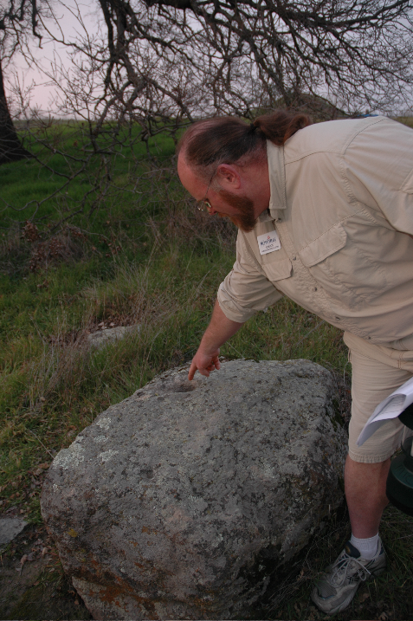

Sacramento Archaeological Society, Inc.

Officers and Directors

President Jan Johansen 530/756-6970 janjohansen@sbcglobal.net
Vice President Anna Valdez 916/628-4226 IndianaAnna@comcast.net
Treasurer Susan W. Ferguson 916/966-4861 susanferguson@comcast.net
Secretary April Farnham 916/371-6806 april_farnham@sbcglobal.net
Past President Dennis T. Fenwick 916/373-1465 Fenwick_lewis@msn.com
Member/Large Ruth McElhinney 916/923-3848 no email
Member/Large Thomas Johansen, MD 530/756-6970 trjohansen@thegrid.net
Member/Large Lydia Peake 916/371-6391 npeake@lanset.com
Member at Large Roger Peake 916/371-6391 npeake@lanset.com
Member at Large Diane Rosales 916/371-4596 drosales@adp.state.ca..us
Member/Large Philomene Smith 916/444-3605 psmit@parks.ca..gov

Mark Your Calendars

Upcoming Society Events

March 3, 2007, Saturday, 6:00 p.m. McGregors, “Peru and Galapagos” at 2825 Butler Court, West Sacramento, (916) 373-1465
March 15, 2007, Thursday, 7:00 p.m. Board Meeting, for location call (530) 756-6970
April 21-22, 2007, weekend, Maturango Museum and Little Petroglyph Canyon Tour, Ridgecrest, CA http://www.maturango.org/pettoursSp07.html

Other Upcoming Events

March 9 – 15, 2007 The Maya Meetings, Austin, TX http://www.utmaya.org/news.html
March 22 – 25, 2007 SCA Conference, San Jose, CA http://www.scahome.org/events/index.html
March 24, 2007 8:00 a.m. to 3:30 p.m. Sutter Buttes Hike: Native Ways Hike, call Middle Mountain Foundation at (530) 671-6116
April 29, 2007 8:00 a.m. to 3:30 p.m. Sutter Buttes: Elder Berry Flute Workshop, call Middle Mountain Foundation at (530) 671-6116

A Non-Profit Corporation
P.O. Box 163287
Sacramento, CA 95816-9287

